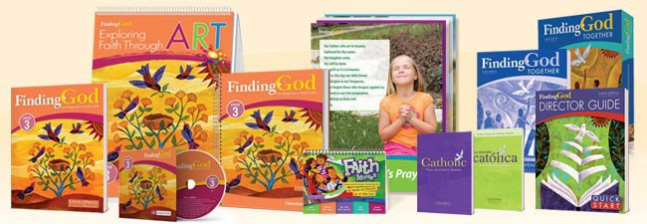

Parish Name:
Catechetical Coordinator:
Catechetical Coordinator’s Phone Number:
Catechetical Coordinator’s Email:
Method of Delivery
Picked up at the Diocese | Delivered
By Whom: When: | How (i.e. Canada Post): Address of where it is to be delivered.
Finding God Catechetical Resources |  | Cost | # of  books | Total Cost
Kindergarten |  | $20.00
Grade 1 |  | $20.00
Grade 2 |  | $20.00
Grade 3 |  | $20.00
Grade 4 |  | $20.00
Grade 5 |  | $20.00
Grade 6 |  | $20.00
Grade 7 with Seasons Magazine |  | $20.00
Grade 8 with Seasons Magazine |  | $20.00
Catholic Prayers for Catholic Families |  | $5.00
TOTAL
Please send your completed order form to ecassistant@padiocese.ca. There are a few copies of the leader resources for all grades still available. Training for new catechists is available via Zoom.
Contact Christine Taylor at 306‐922‐4747, ext. 227 or catechetics@padiocese.ca, with any requests.
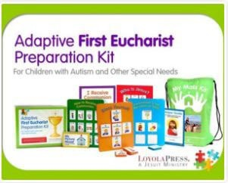
For children with special needs, there are also resources available for first reconciliation, confirmation, and first communion preparation that can be borrowed from the Diocesan Resource Centre. Call Debbie McHarg at 306‐922‐4747 extension 229 or
via email at mailto:resource@padiocese.ca

