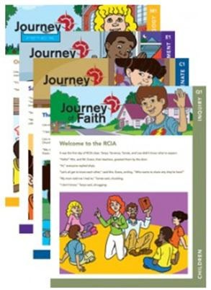
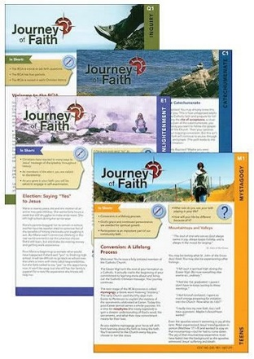
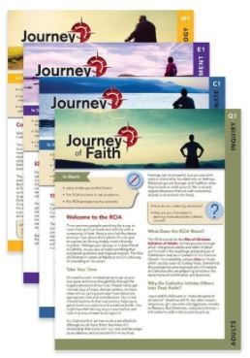

Parish Name:
RCIA Coordinator:
RCIA Coordinator’s Phone Number:
RCIA Coordinator’s Email:

Method of Delivery
Picked up at the Diocese | Delivered
By Whom: When: | How (i.e. Canada Post): Address of where it is to be delivered.

Journey of Faith Packets | Cost | # of packets | Total Cost
**Children (10 - 12 years) | $30.00
Teen (13 - Grade 12) | $30.00
Adult | $30.00
Catholic Prayers for Catholic Families (Purple Book) | $5.00
Shipping Cost
TOTAL
**The age range depends on the maturity and group you have who are entering the journey.
(i.e., A young ten year old’s parents take the baptism prep sessions and the child with their parents enters the preparation journey for confirmation and first communion provided by the parish. A mother with three teenagers can use the teen journey material with her three teenage children. A 12‐year old can do the teen journey with their 14‐year old brother or vice versa, depending on the maturity of the children.

Leader’s guides can be borrowed from the Oﬃce of Evangelization and Catechesis.

Training for new catechists is available via Zoom, contact Christine Taylor at 306‐922‐4747 ext. 227 or via email at catechetics@padiocese.ca.

Please email your order sheet to Nicole Ferchuk at ecassistant@padiocese.ca.

