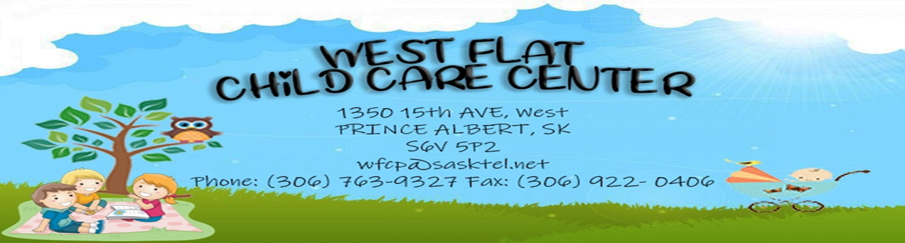

West Flat Child Care Center
Prince Albert, SK S6V 5P2
1350 15th Ave West
(306) 763-9327
wfcp@sasktel.net

Tuesday, June 24th, 2025
To the Board of Directors of the Prince Albert Diocese,
The West Flat Child Care Center would like to thank the Board of Directors of the Diocese of Prince Albert. Our childcare center put in an application under the Indigenous Reconciliation fund for a donation of $7,000.00 towards Indigenous play items, such as dolls, puppets, finger puppets, stuffies, natural blocks and natural items. This was so exciting for us as a child care center to order Indigenous toys, play items and resources. When we started bringing the Indigenous dolls, puppets, stuffies, toys and natural blocks and items into all the classrooms. The children were so excited, thrilled and the smiles on their faces were just the best! We did this at the beginning of April and still the children are enjoying all that was purchased for them. It encourages positive self-esteem and self-confidence. It fosters a strong sense of identity for the little ones. The children were beeming so bright with the new stuff. It has fostered creativity, exploration, play and language, independence, growth and their overall long-term development and life outcomes. They kept coming to ask me what are you bringing in next. They were smiling, laughing, playing, exploring, it was just great to witness the excitement from them. I was super happy that they loved their new stuff.
We are very appreciative of being approved for the IRF grant! It has provided many meaningful opportunities and experiences for our children here at our center. Please accept our sincere gratitude for this opportunity.
Thank you! Thank you! Thank you!

Loretta Vandale, director

